**1. Create 2 new components (WarningAlert and SuccessAlert)**

**2. Output them beneath each other in the AppComponent**

**3. Output a warning or success message in the components**

**4. Style the components appropriately.**

**5. Bring both the components to the output screen by adding the selector name of each component as tag name in app.component.html.**

1. Create 2 new components (WarningAlert and SuccessAlert)

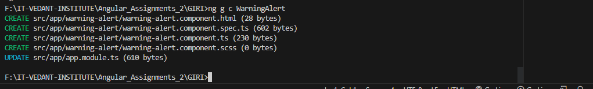

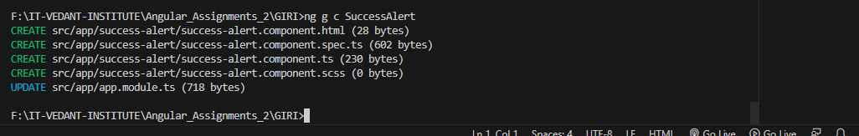

4. Style the components appropriately.

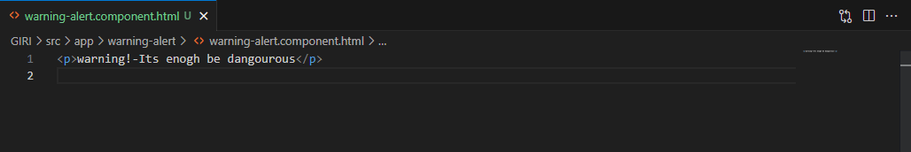

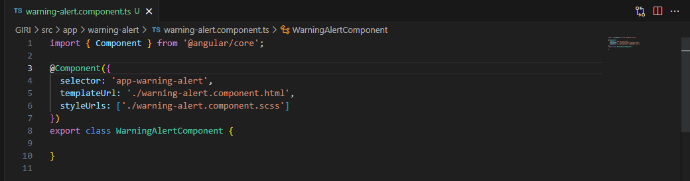

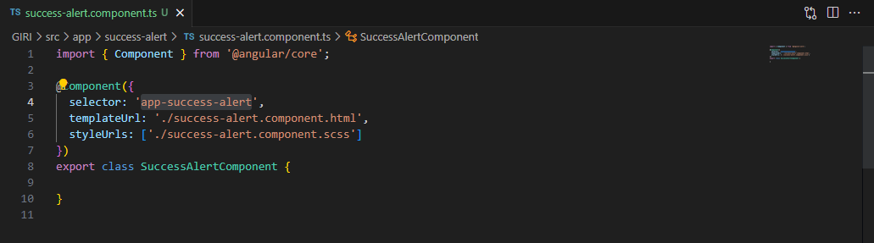

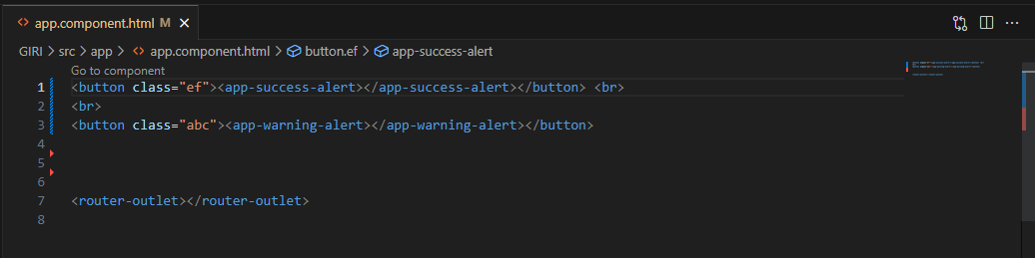

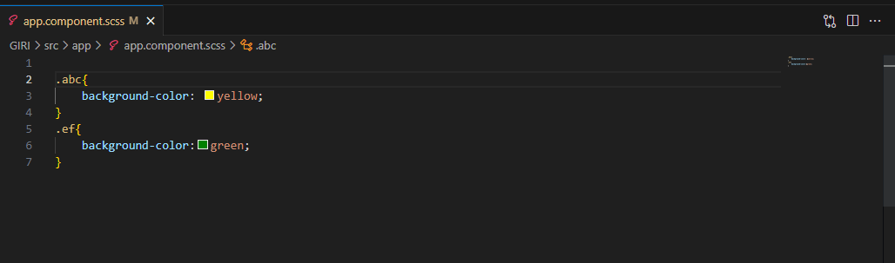

5. Bring both the components to the output screen by adding the selector name of each component as tag name in app.component.html.

